# CS 340 README

## About the Project/Project Title

This project provides me, a software engineer for Global Rain, the opportunity to work on code for an innovative international rescue-animal training company. This company, Grazioso Salvare, has hired me as the lead developer to create a software application which can work with existing data from animal shelters to identify and categorize available animals. This represents a full-stack development cycle which will include a database and a client-facing web application dashboard.

In this specific phase of development, I have developed a portable Python module that enables CRUD functionality for the data connection to the animal database. This module has create and read functionality with plans for update and delete at a later stage. The goal of this module will be to connect the user-interface to the database, which will have full functionality at a future stage. This also includes a fully functional dashboard which allows the user to organize the available animals, see their location, and see them on a pie chart.

## Motivation

The motivation behind this project is based on the goals of Grazioso Salvare. This company identifies dogs that are good candidates for search-and-rescue training. The dogs that are successfully trained are able to find and help rescue humans and other animals who are often in life-threatening situations. Grazioso Salvare has an agreement with an existing nonprofit agency who manages five animal shelters around Austin, Texas. Grazioso needs an application that can aid in using the data from these shelters to aid in the selection process.

## Getting Started

To initiate a local copy of this database and python functionality, first the shelter’s csv file must be imported using a mongo import command in the terminal with the local datasets location selected.

Following this the appropriate users and access privileges must be created.

The user privileges require the port being used to be determined. This can be done by using the printenv command in the Linux shell.

The Mongo Client and object functionality must also be imported.

Following this, access to the database can be tested using the appropriate user parameters and database commands. This can be done in the terminal, or in Jupyter Notebook.

Jupyter Notebook is the recommended method for creating all necessary code and testing it for functionality. After this, the code can be copied and created as a py file in your preferred IDE.

PyMongo must also be installed as functionality of the database and python module is dependent on this.

## Installation

The tools that were used in this project are as follows and are provided with a link for installation:

Linux Operating System and Terminal

This can be installed via the open-source Linux versions:

<https://www.linux.org/pages/download/>

In my specific project, Linux is installed on an online virtual desktop known as apporto. More information can be found here:

<https://www.apporto.com/>

Jupyter Notebook can be installed from its website:

<https://jupyter.org/>

Installation instructions are here: <https://jupyter.org/install>

RStudio installation instructions are found here:

<https://rstudio-education.github.io/hopr/starting.html>

This was used for implementation of the py file containing the python module.

Firefox was the preferred browser; however other browsers can also be used.

The Firefox installation can be found here:

<https://www.mozilla.org/en-US/firefox/linux/>

MongoDB is the database structure used in this project. Installation instructions can be found here:

<https://www.mongodb.com/docs/manual/installation/>

PyMongo is also a necessary dependency and can be found here:

<https://www.mongodb.com/docs/languages/python/pymongo-driver/current/get-started/download-and-install/>

Dash Core Components, DataTable, and Leaflet are necessary imports for the dashboard functionality. Links describing this functionality are provided here:

<https://dash.plotly.com/dash-core-components>

<https://dash.plotly.com/datatable>

<https://dash-leaflet-docs.onrender.com/>

The Plotly library is used in Python in order to create the pie chart. Details are provided here:

<https://plotly.com/python/pie-charts/>

**Purpose of Python Module**

The Python Module is used to enable CRUD functionality for the database. A CRUD class contained in the module completes four main functions: Create, Read, Update, and Delete. The Create method inserts a document into a specified MongoDB database and collection., The Read method queries for documents from a specified MongoDB database and collection. The Update method allows users to query and change documents from a specified MongoDB database and collection. The Delete method allows users to query and delete documents from a specified MongoDB database and collection. These methods represent the main purpose of the Python module.

**Purpose of the Dash framework**

The Dash framework used in this code provides the view and controller structure for the web application. This includes the ability to determine the functionality and visual style of the dash with which users will interact in order to organize the available animals. The Dash core components allow the interface to be built and determine user interface interactivity. The Dash DataTable is responsible for implementation of the data table containing all of the animals and their filters. Dash Leaflet allows for the creation of the geolocation chart showing the animal locations.

## Usage

The primary functional code is the python module, which is shown in the following code example. Testing usage of the module is also shown. The module is used to complete all CRUD operations on a MongoDB database.

### Code Example

First, the Austin Animal Center Outcomes data set must be uploaded into MongoDB by inserting a CSV file with the appropriate MongoDB import commands. This is shown via the mongoimport tool here:

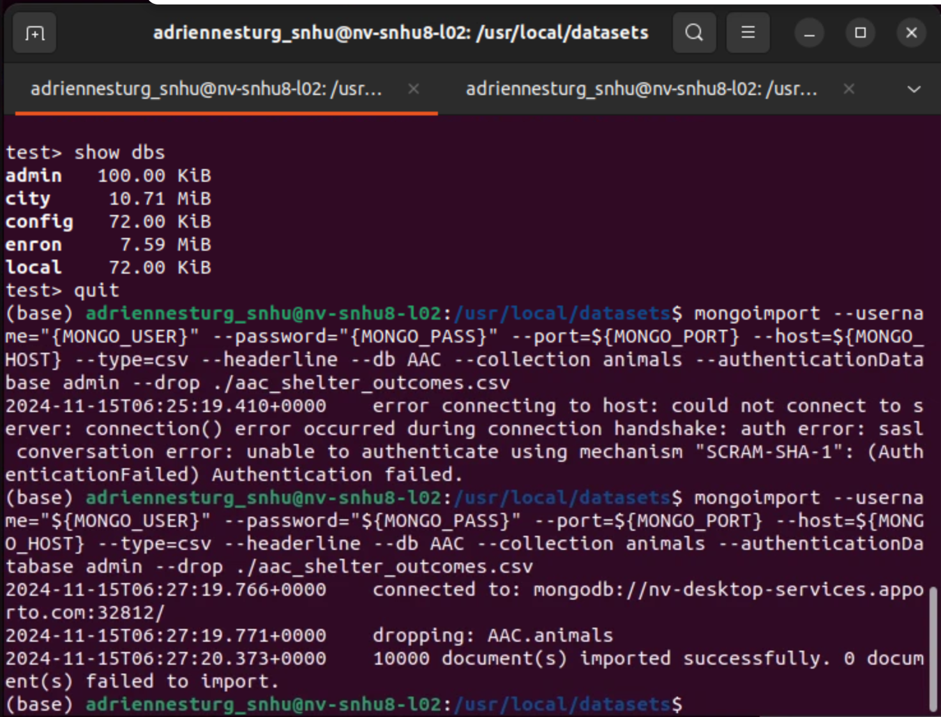

Testing the mongo shell is also shown:

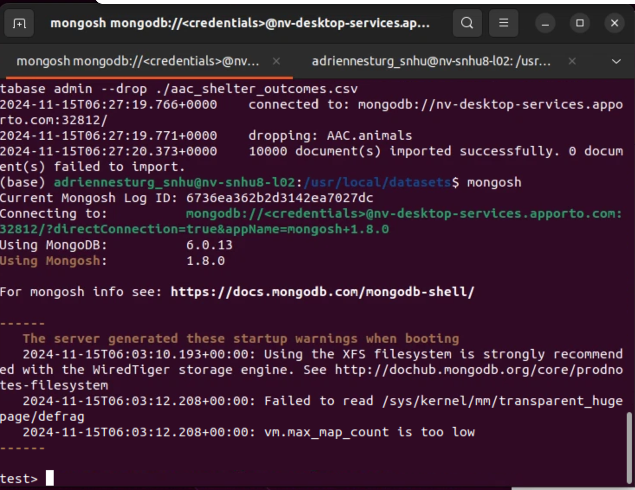

Next, a user account must be created to ensure user authentication to the database and collection that is being used. A login test is also shown:

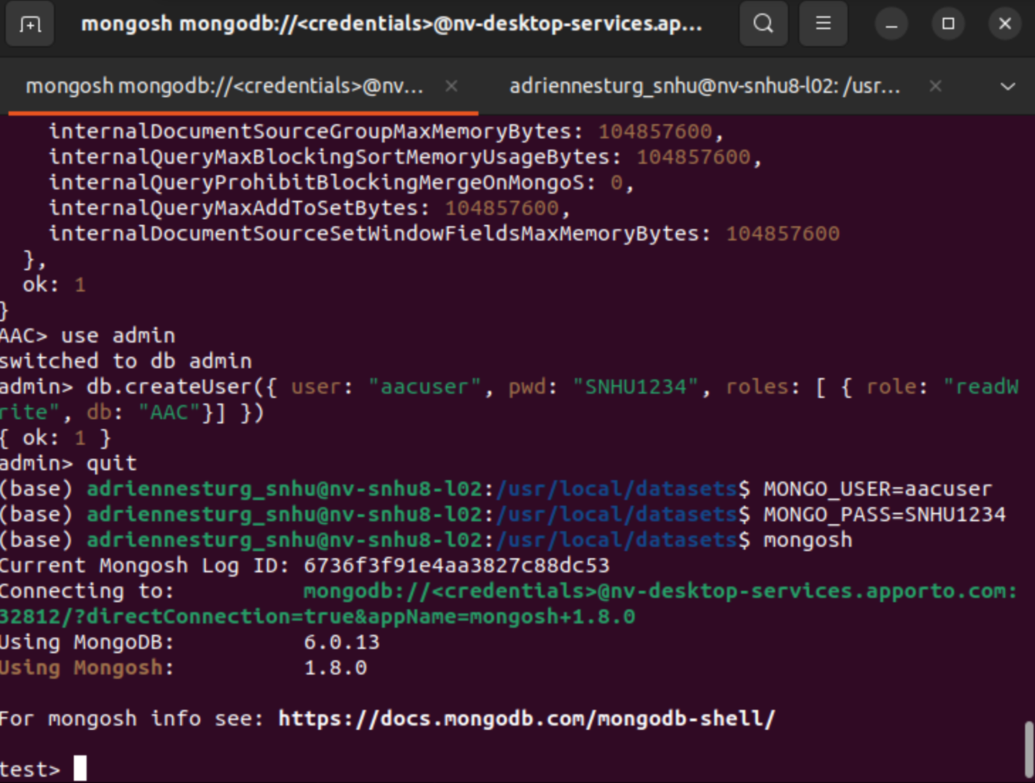

In addition to these setup steps, the Python Module which contains the CRUD methods is made and shown here:

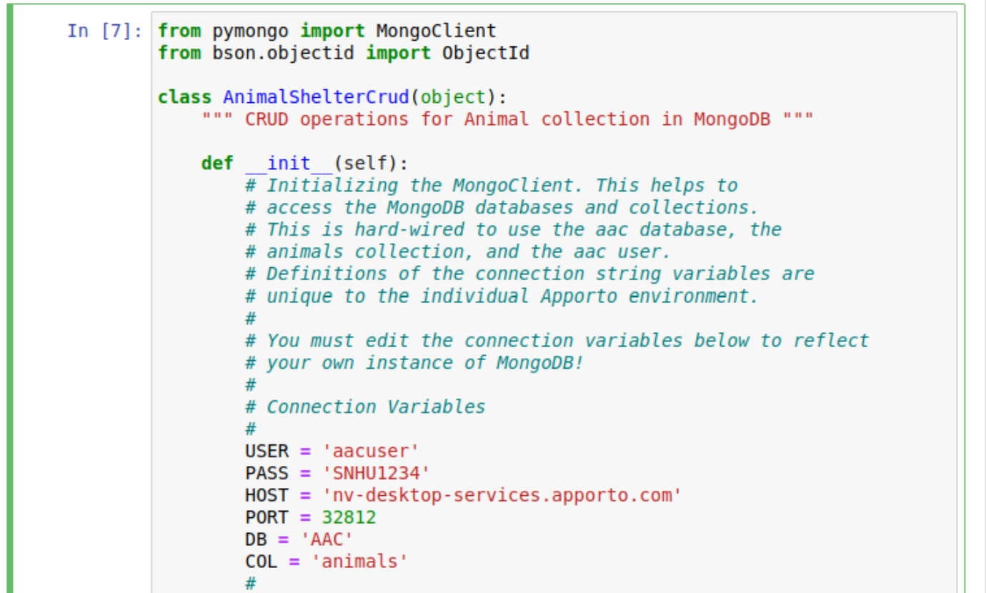

This demonstrates the use of user fields previously created in the terminal for MongoDB.

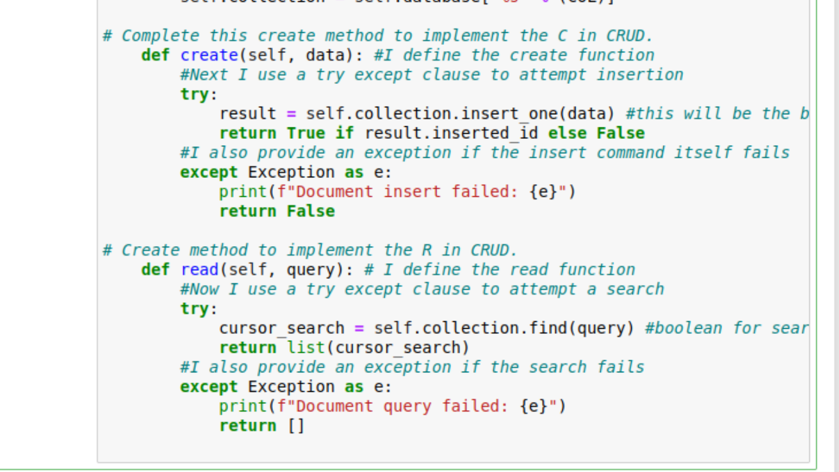

This shows the create and read code which represents the primary functionality of the Python Module. The update and delete methods are shown below:

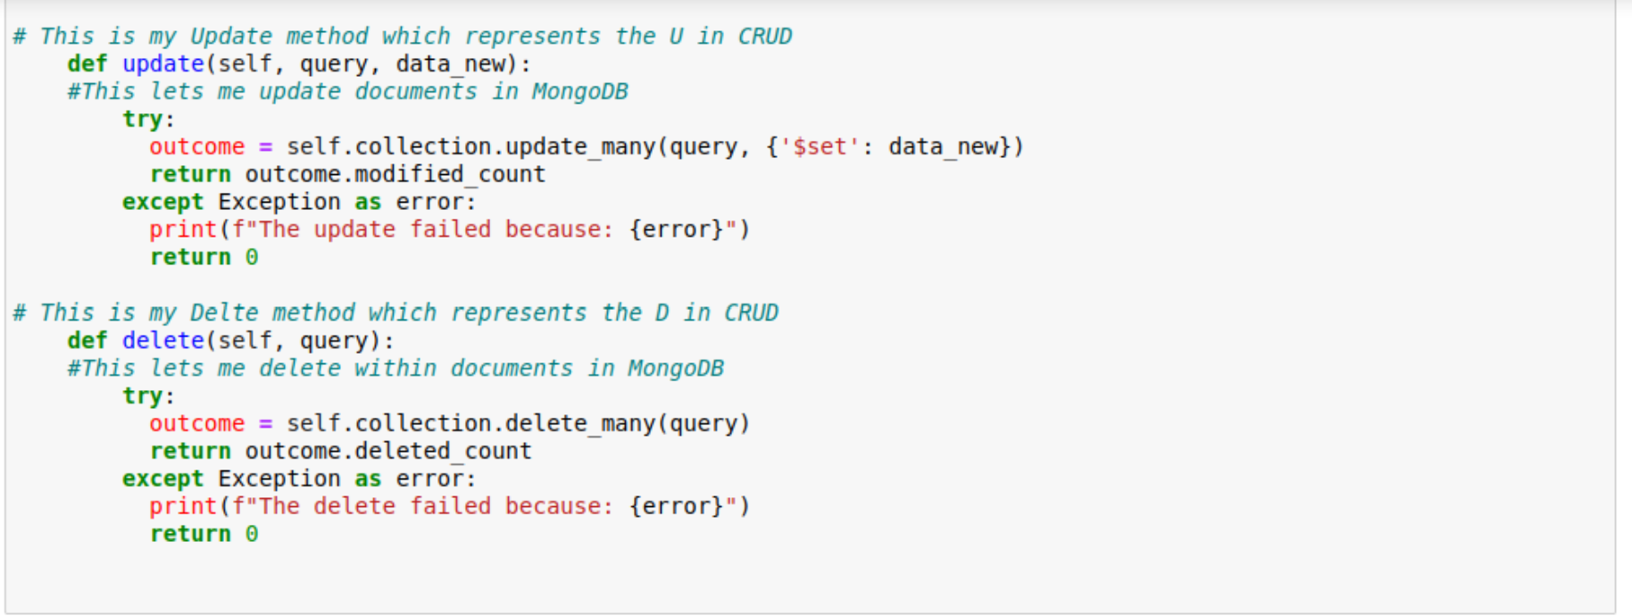

Update and delete methods follow the same coding style and format as the previous methods.

### Tests

Tests were completed by initializing an animal object and then attempting the create and read methods for the test animal. This is shown here:

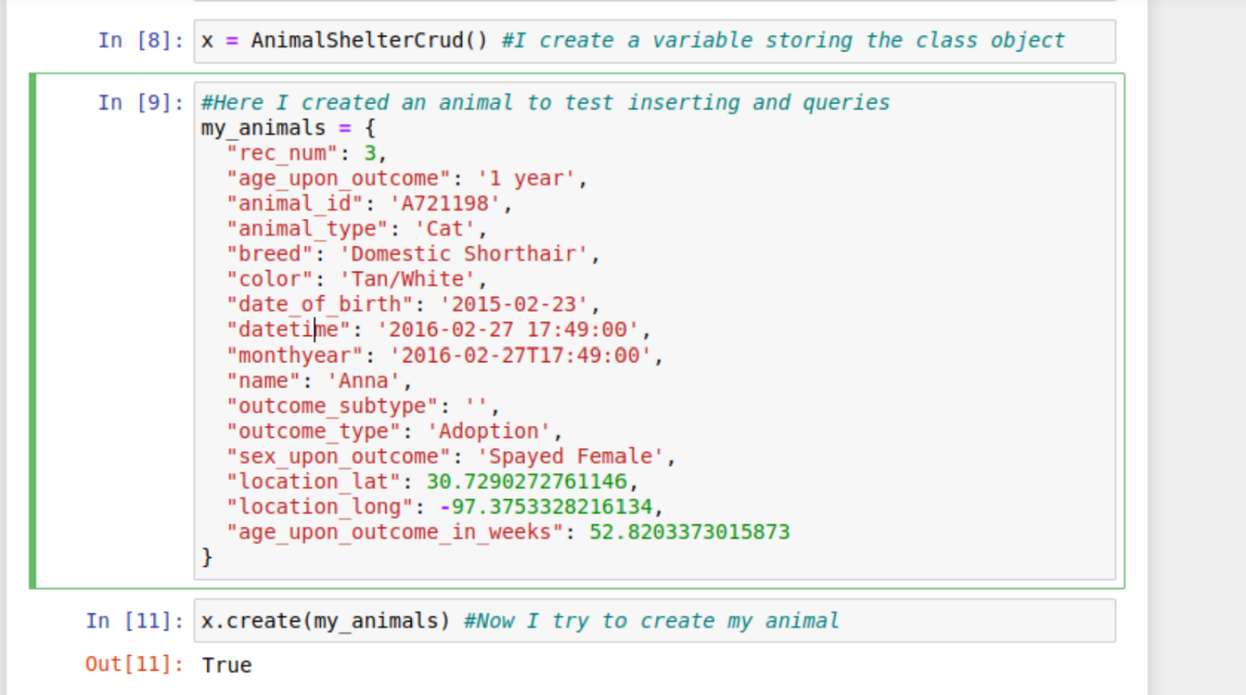

First, the create method is tested with a successful True Boolean response.

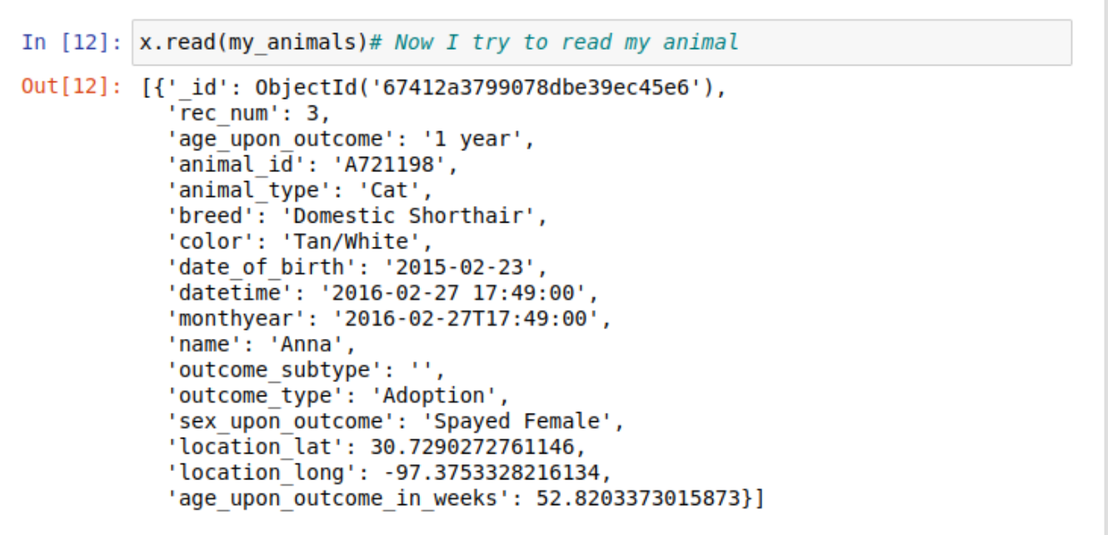

Next, the read functionality is tested with successful output.

Following this tests were completed for the update and delete methods:

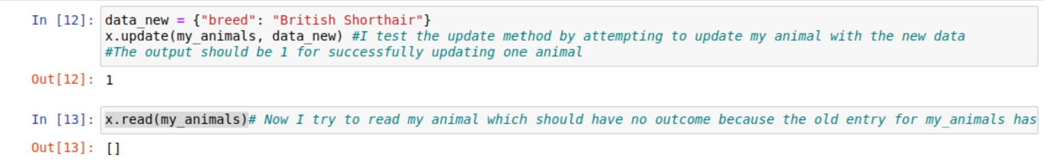

This represents the update method tests, which produces no output for the read command because the animal was successfully updated. This means that the previous version of the animal no longer exists.

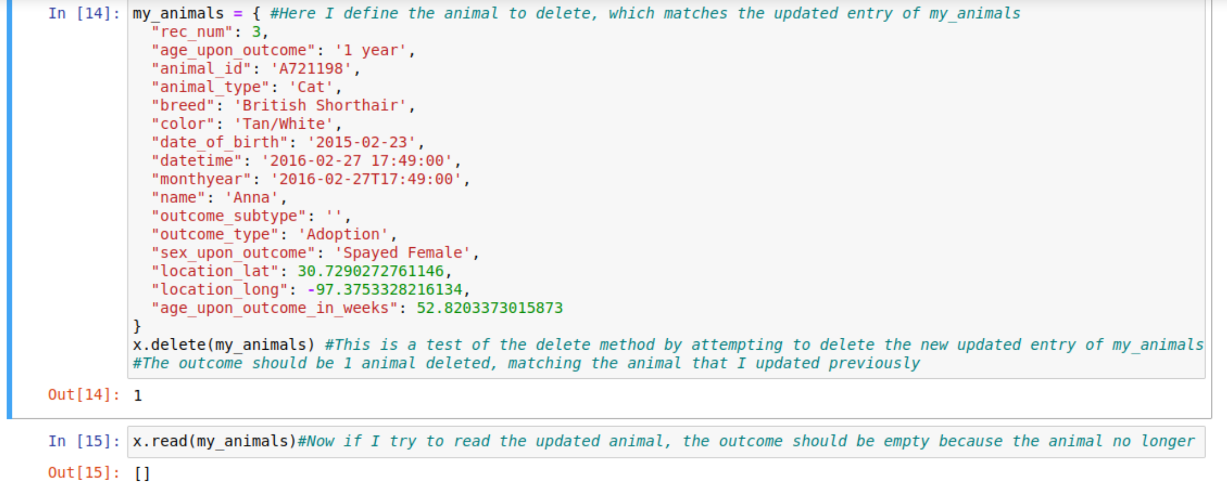

This is the delete method test, which also has no output because the animal no longer exists once the read command is called.

Next the code for the dashboard is shown:

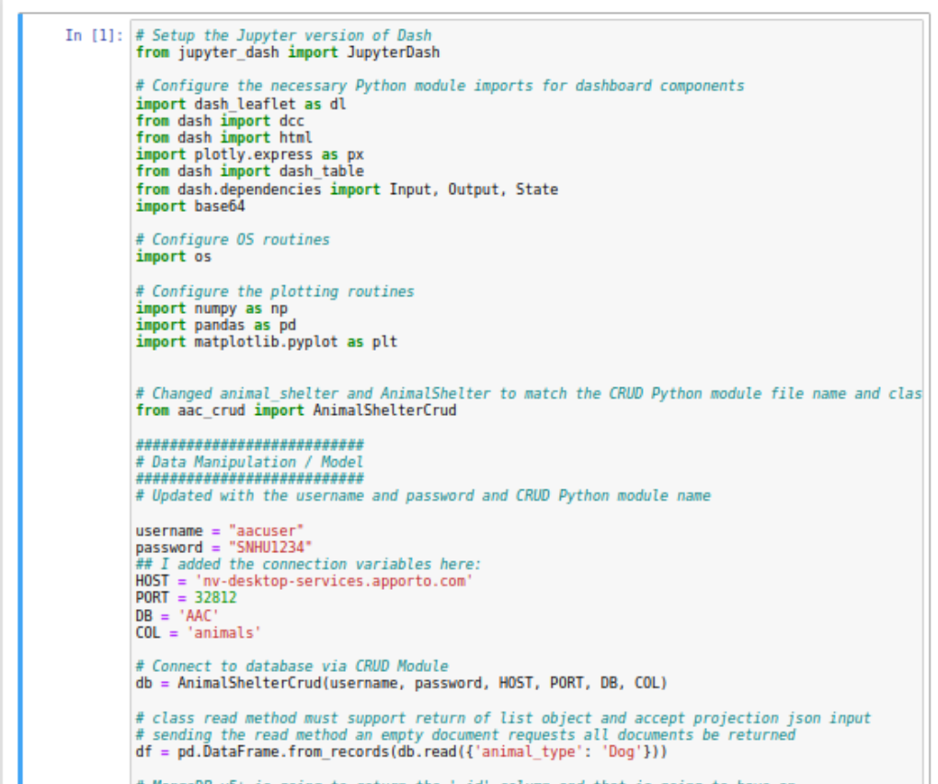

This demonstrates the necessary setup for the dashboard.

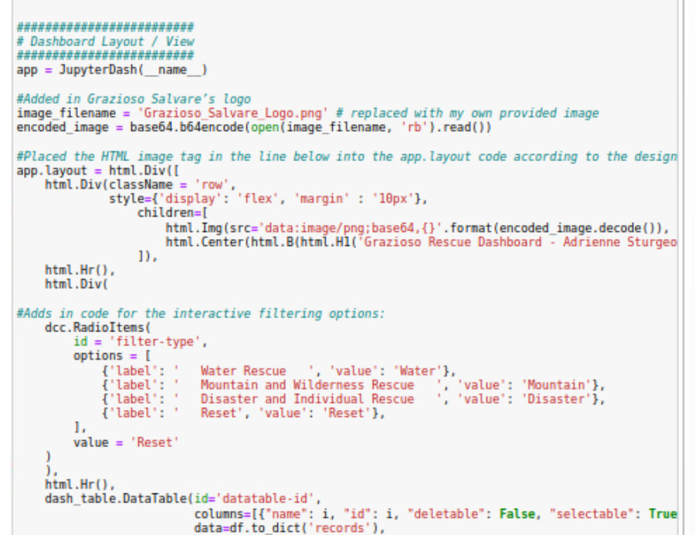

Here is shown the dashboard image and radio buttons.

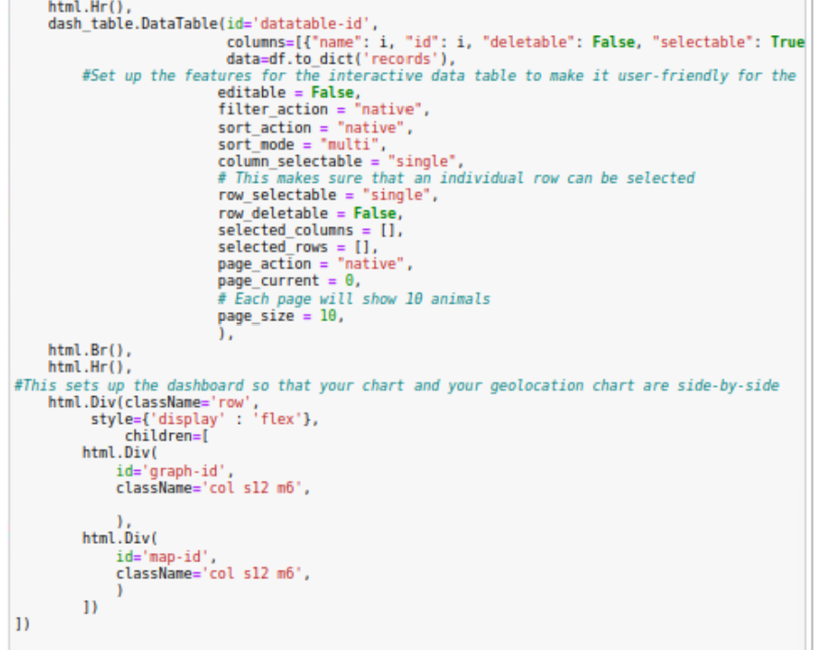

This shows the dash data table and positioning of the chart and map.

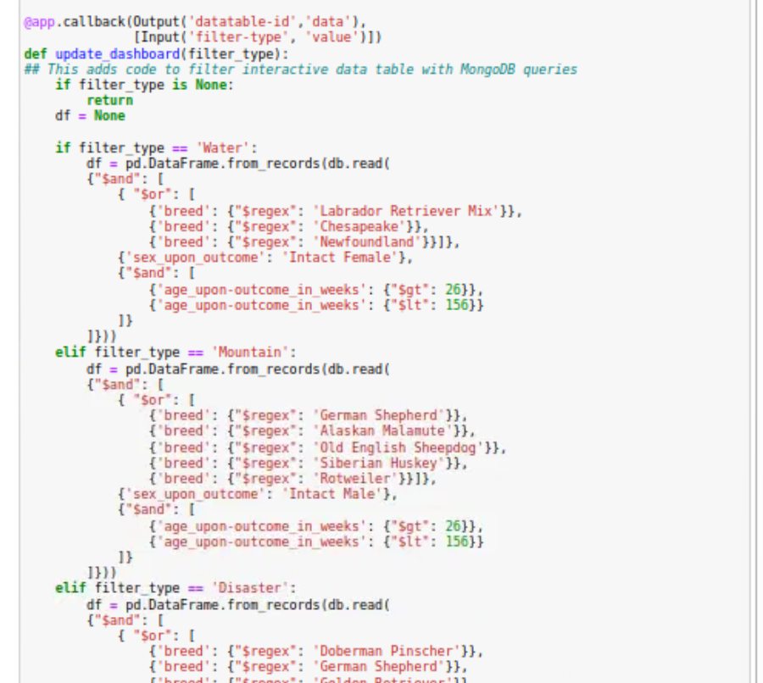

Here is shown the code which allows filtering of the animals.

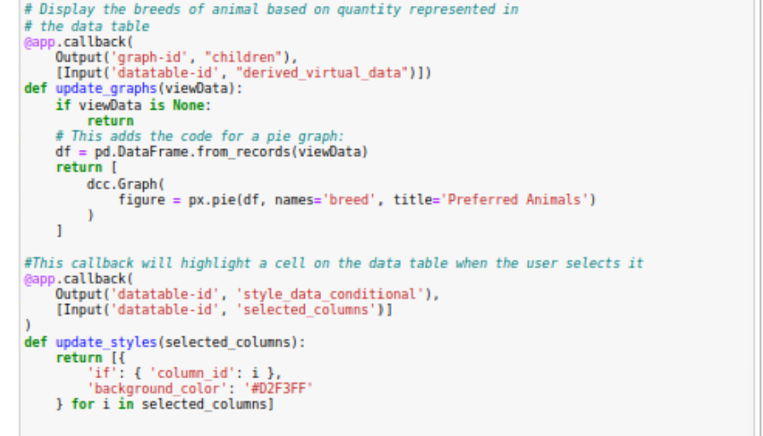

This shows the callbacks for displaying the breeds based on quantity and the ability to highlight cells in the table.

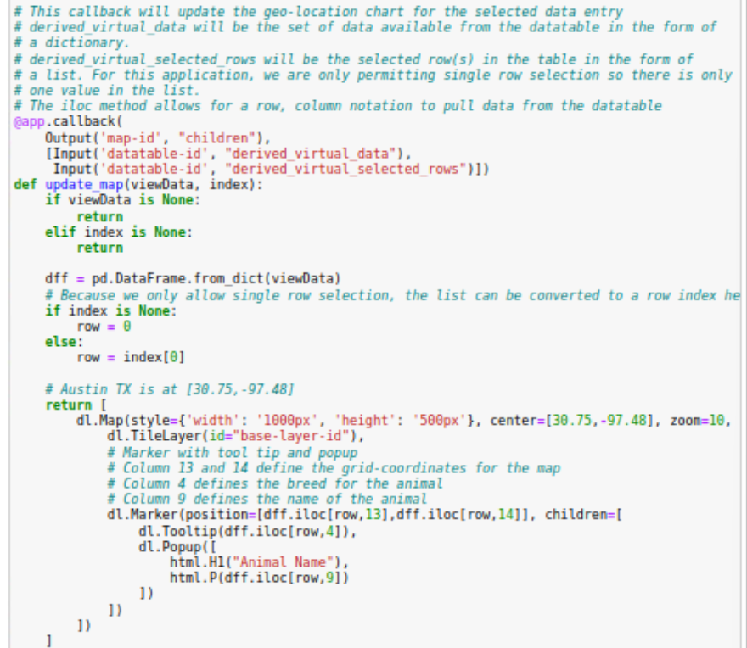

This is the code which allows the geo-location chart to update with the appropriate animal location and description.

### Screenshots

Previous screenshots have been provided; however additional screenshots have been placed here to showcase my work:

Import command for csv file:



Testing the mongo shell:



Printenv command:

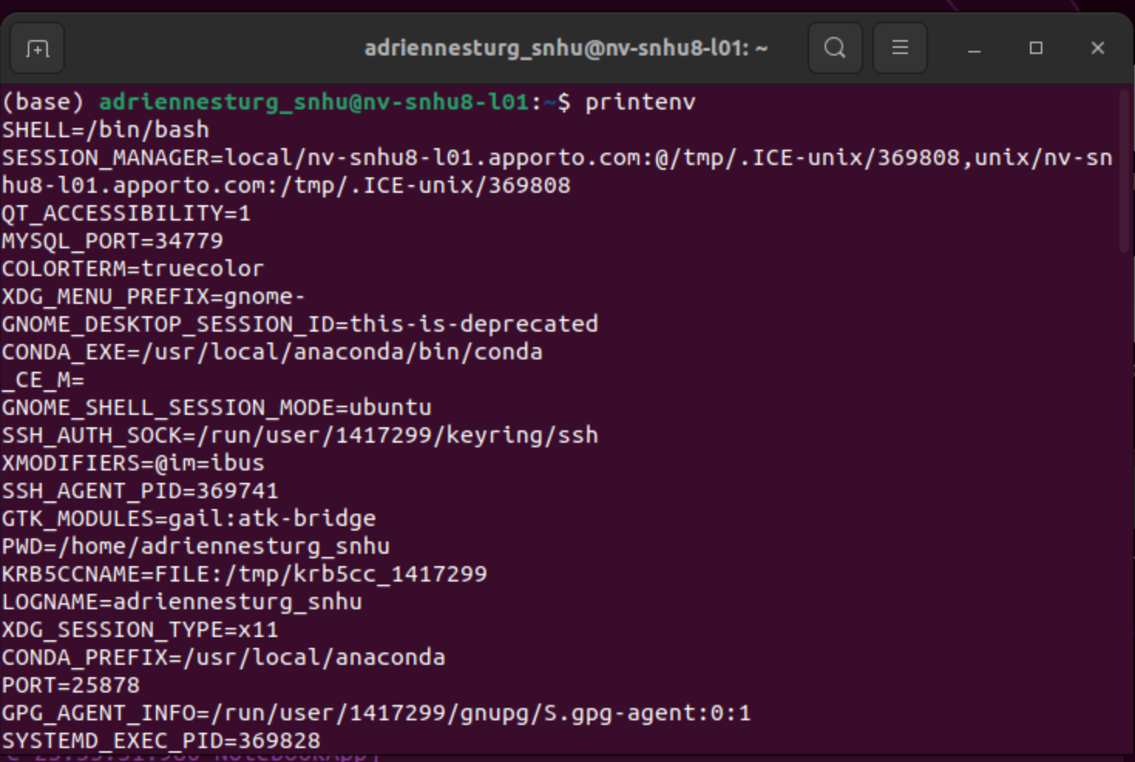

**Dashboard Example screenshots**

This shows the successful implementation of the dashboard:

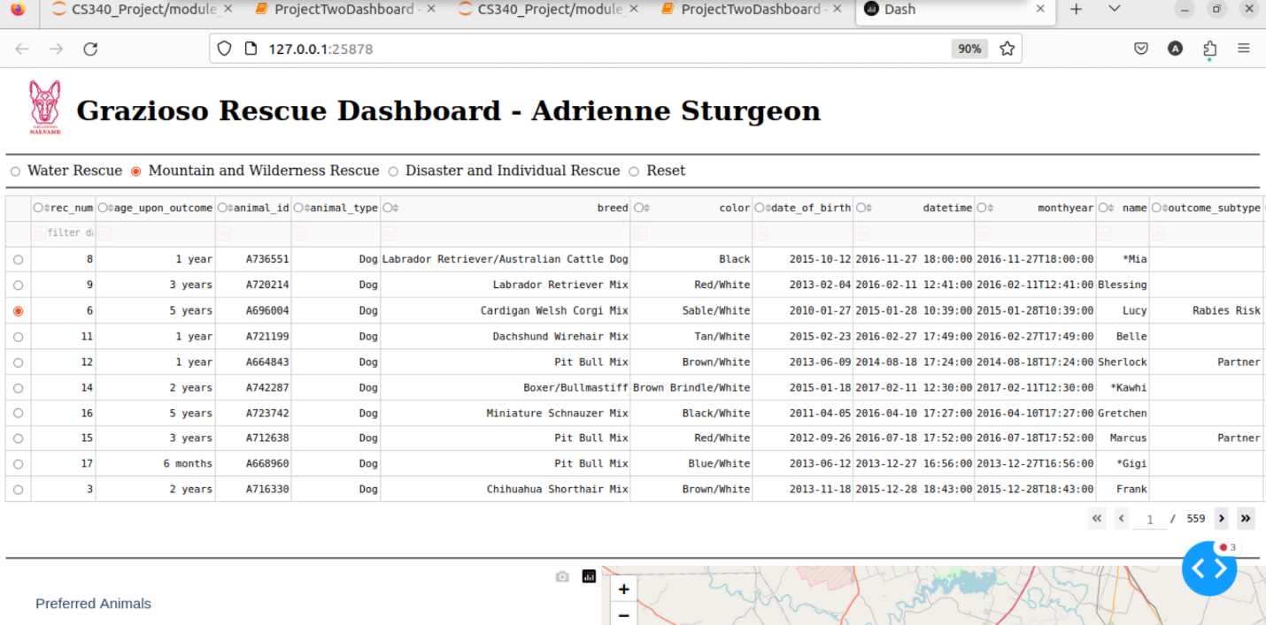

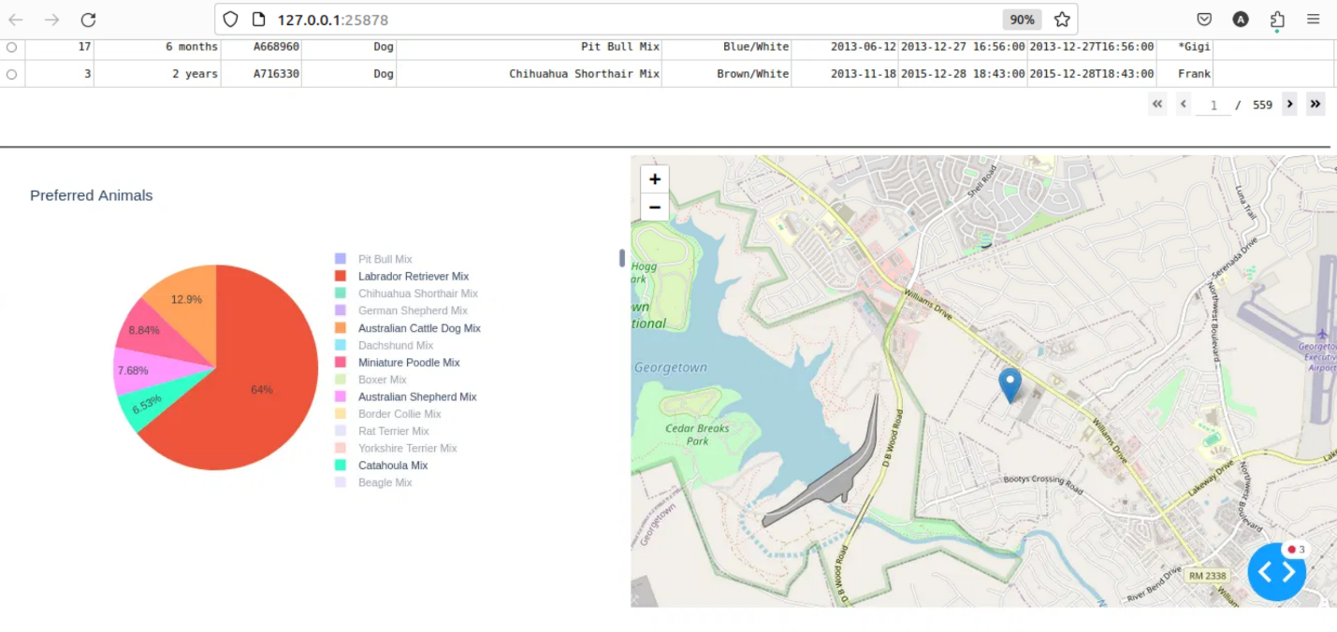

## Roadmap/Features (Optional)

The Project has now entered the maintenance cycle and will be monitored and improved based on performance metrics.

**Challenges**

The primary challenge presented in this project was when working within the terminal to complete the necessary imports, user profile setup, and testing. The terminal has no review of code and does not allow for any mistakes. This meant that time had to be dedicated to perfection of queries and code in order to ensure that each command executed as expected.

An additional challenge was determining syntax errors when creating the code for the dashboard. The filters and other stylistic code had a large amount of very specific formatting that was easy to make mistakes with. This problem was overcome by utilizing debugging and error reports to successfully determine the location of the corresponding error.

## Contact

Adrienne Sturgeon